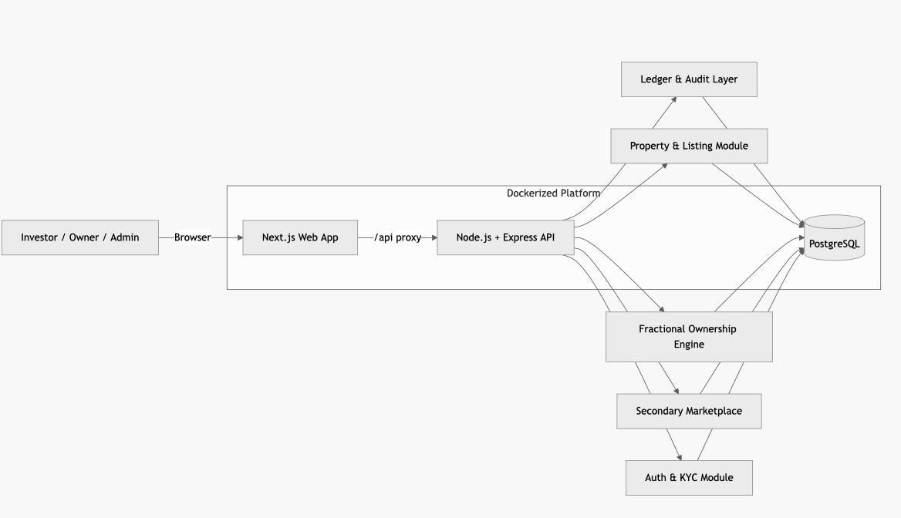

flowchart LR
User[Investor / Owner / Admin] -->|Browser| Web[Next.js Web App]
Web -->|/api proxy| API[Node.js + Express API]

API --> Auth[Auth & KYC Module]
API --> Listing[Property & Listing Module]
API --> Invest[Fractional Ownership Engine]
API --> Market[Secondary Marketplace]
API --> Ledger[Ledger & Audit Layer]

Ledger --> DB[(PostgreSQL)]

Listing --> DB
Invest --> DB
Market --> DB
Auth --> DB

subgraph Dockerized Platform
Web
API
DB
end

